MediaBazaarSolution

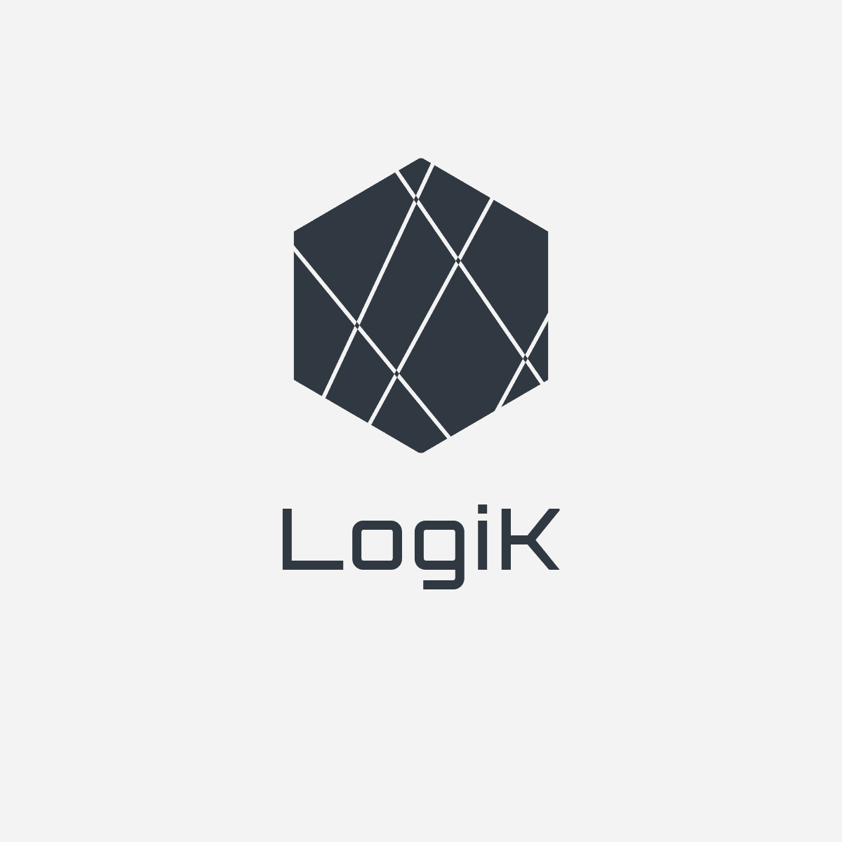

CB06

Colin Polder

Daniel Vaswani

Khoa Doan

Georgi Nikolov

# Progress Table

|  |  |  |  |  |
| --- | --- | --- | --- | --- |
|  | Discussions | Agreements | Activities | Achieved |
| Week 1 | Choosing the general layout of the application and work ethic. | Work ethic was chosen as assigned task driven. | General layout of the application was laid down. Initial template of the project plan was made. | Logo  Project plan v1 |
| Week 2 | Reflection on the project plan and initial foundations of the URS. | General layout of URS was decided upon. | Project plan was improved, URS was laid down. | Project plan v2  URS v1 |
| Week 3 | Reflection on the URS and team roles. | Colin would be team leader and contact person. General tasks were divided. | URS was improved. UML were made for the application, basic idea was made for website. | URS v2  UML application  HTML website |
| Week 4 | UML application were discussed. HTML was discussed. | HTML was fine. UML made by Colin would be used as general idea of UML for the entire project. | Making of the initial UI of the application.  Making part of the back end of the website. |  |
| Week 5 | UI was discussed, checked for extra activities. Some things happened on Git and git usage was also discussed. | You would upload right after pulling your part to make sure you don’t overwrite others’ work. | Making the rest of the back end.  Part of fixing the UI of the application. | Back end of the website. |
| Week 6 | Test plan/report were discussed. Presentation was discussed. | Colin would make initial documents, and others would improve on Colin’s work. | Making of the presentation and test plan/report. | Test Plan  Test Report  Presentation |